Week 03

**Question 1:**

**Write a program to read two integer values and print true if both the numbers end with the same digit, otherwise print false. Example: If 698 and 768 are given, program should print true as they both end with 8.**

**Sample Input 1:**

**25 53**

**Sample Output 1:**

**false**

**Program:**

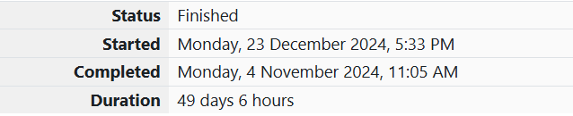

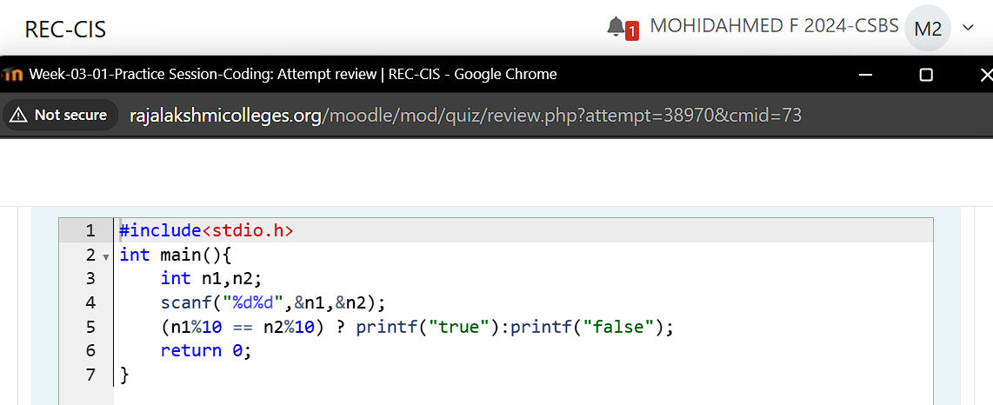

**Output:**

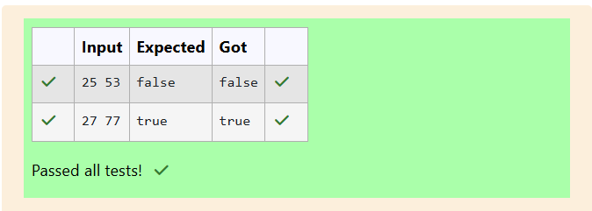

**Question 2:**

**Given an integer, *n*, perform the following conditional actions:**

**·         If *n* is odd, print Weird**

**·         If *n* is even and in the inclusive range of *2* to *5*, print *Not Weird***

**·         If *n* is even and in the inclusive range of *6* to *20*, print *Weird***

**·         If *n* is even and greater than *20*, print *Not Weird***

**Input Format: A single line containing a positive integer, *n*.**

**Sample Input 1:**

**3**

**Sample Output 1:**

**Weird**

**Program:**

** **

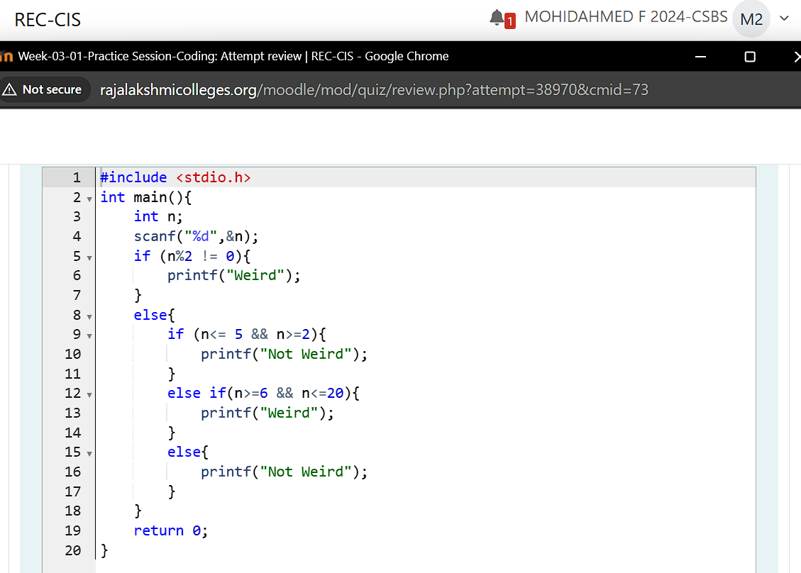

**Output:**

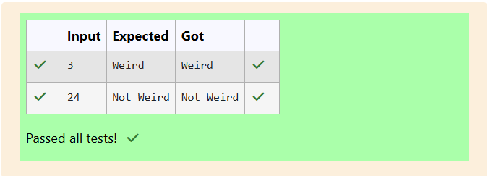

**Question 3:**

**Three numbers form a Pythagorean triple if the sum of squares of two numbers is equal to the square of the third. For example, 3, 5 and 4 form a Pythagorean triple, since 3*3 + 4*4 = 25 = 5*5 You are given three integers, a, b, and c. They need not be given in increasing order. If they form a Pythagorean triple, then print "yes", otherwise, print "no". Please note that the output message is in small letters.**

**Sample Input 1:**

**3 5 4**

**Sample Output 1:**

**yes**

**Program:**



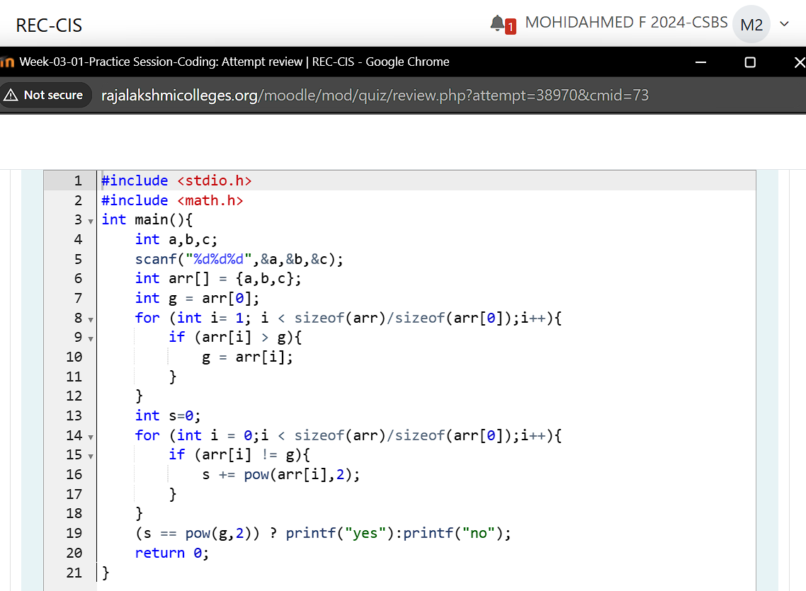

**Output:**

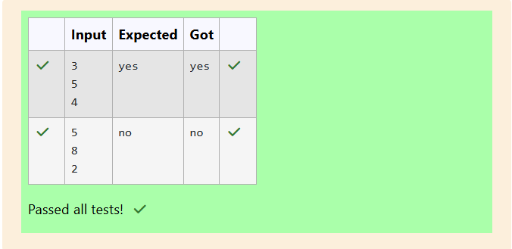

**Question 4:**

**Write a program that determines the name of a shape from its number of sides. Read the number of sides from the user and then report the appropriate name as part of a meaningful message. Your program should support shapes with anywhere from 3 up to (and including) 10 sides. If a number of sides outside of this range is entered then your program should display an appropriate error message.**

**Sample Input 1:**

**3**

**Sample Output 1:**

**Triangle**

**Program:**

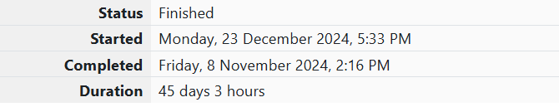

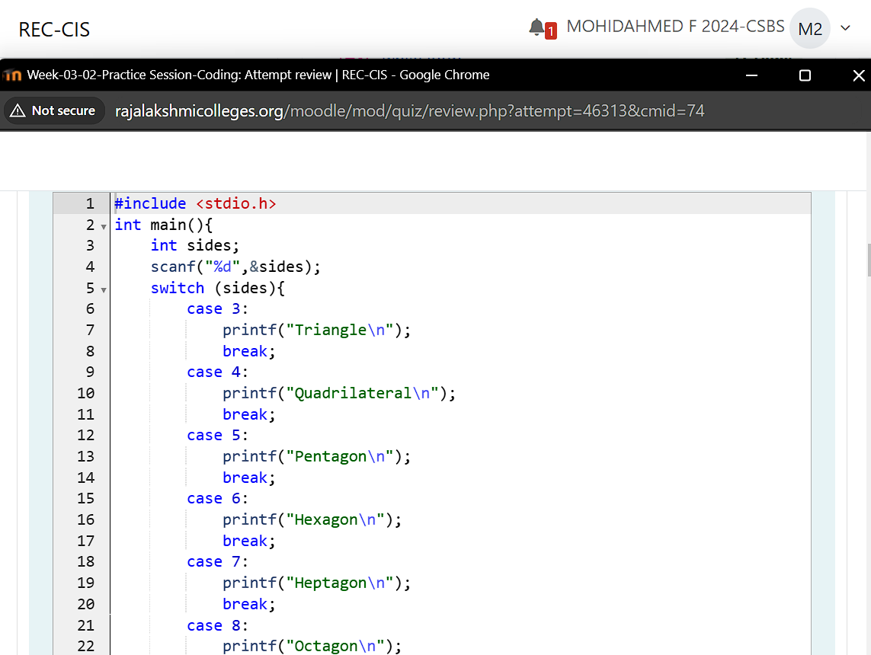

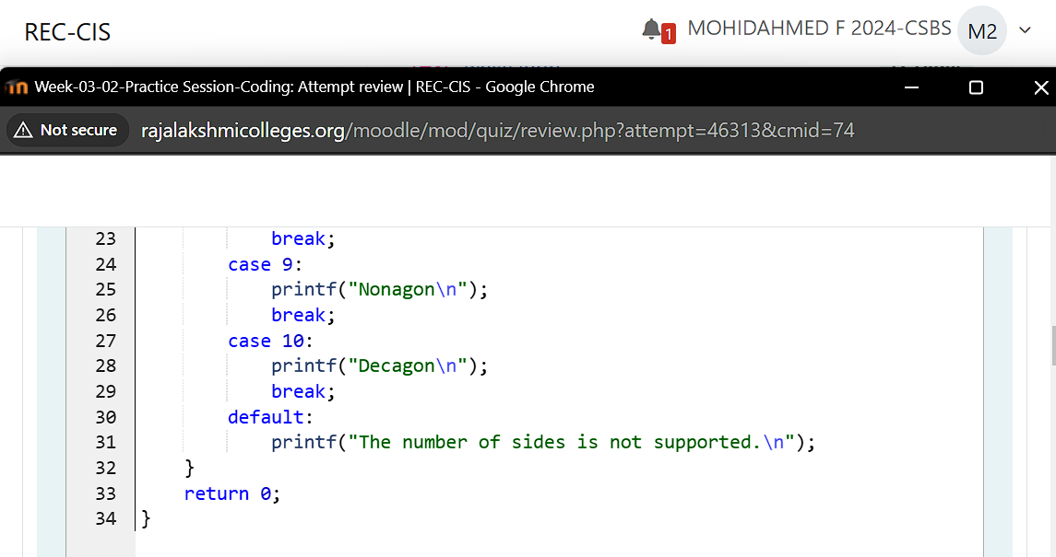

**Output:**

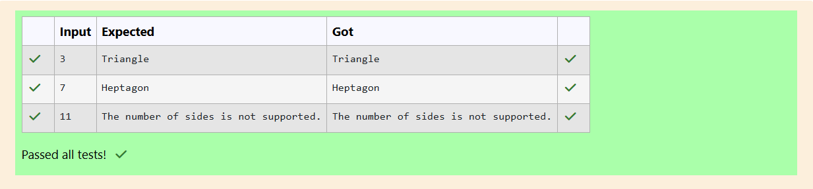

**Question 5:**

**The Chinese zodiac assigns animals to years in a 12-year cycle. One 12-year cycle is shown in the table below. The pattern repeats from there, with 2012 being another year of the Dragon, and 1999 being another year of the Hare.**

**2000-Dragon 2001-Snake 2002-Horse 2003-Sheep 2004-Monkey 2005-Rooster 2006-Dog 2007-Pig 2008-Rat 2009-Ox 2010-Tiger 2011-Hare**

**Write a program that reads a year from the user and displays the animal associated with that year. Your program should work correctly for any year greater than or equal to zero, not just the ones listed in the table.**

**Sample Input 1:**

**2004**

**Sample Output 1:**

**Monkey**

**Program:**



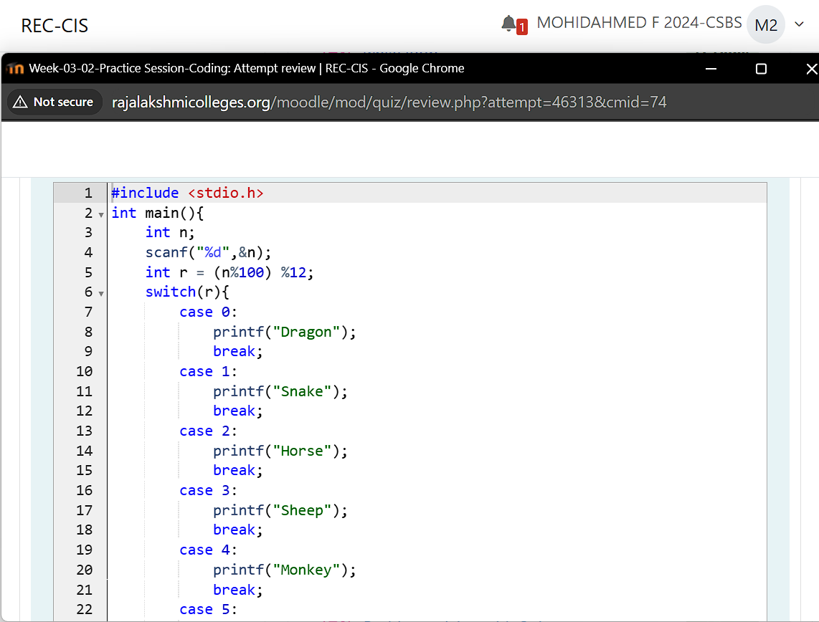

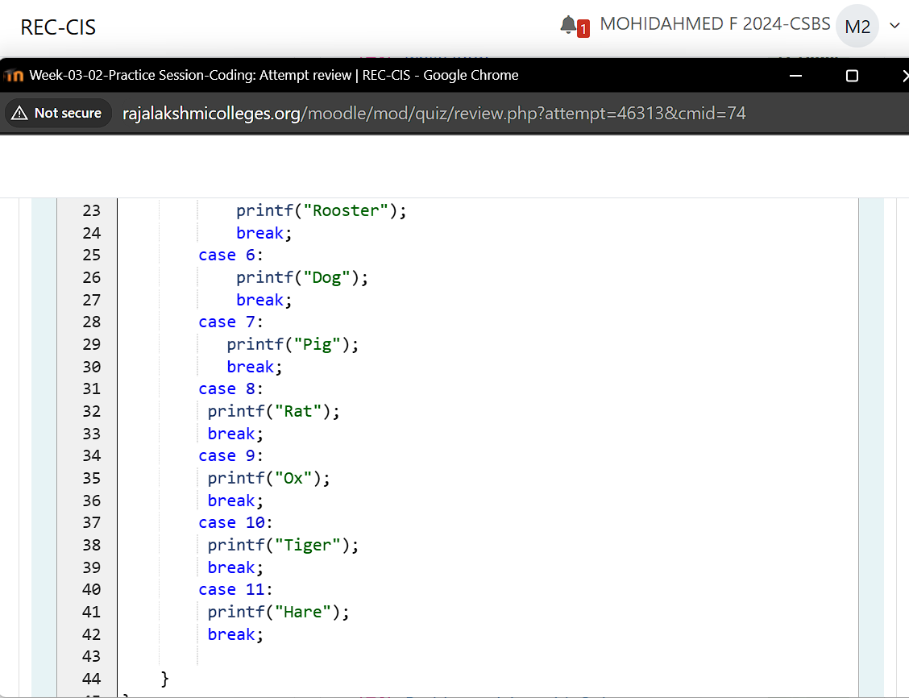

**Output:**

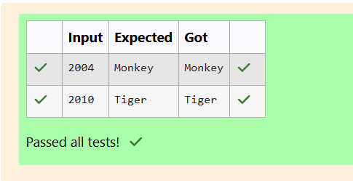

**Question 6:**

**Positions on a chess board are identiﬁed by a letter and a number. The letter identiﬁes the column, while the number identiﬁes the row, as shown below:**

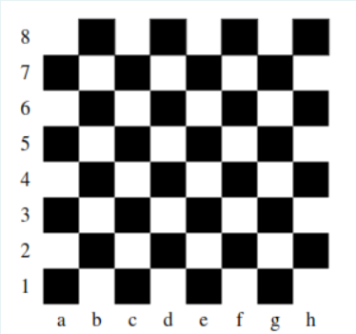

**Write a program that reads a position from the user. Use an if statement to determine if the column begins with a black square or a white square. Then use modular arithmetic to report the color of the square in that row. For example, if the user enters a1 then your program should report that the square is black. If the user enters d5 then your program should report that the square is white. Your program may assume that a valid position will always be entered. It does not need to perform any error checking.**

**Sample Input 1:**

**a 1**

**Sample Output 1:**

**The square is black.**

**Program:**



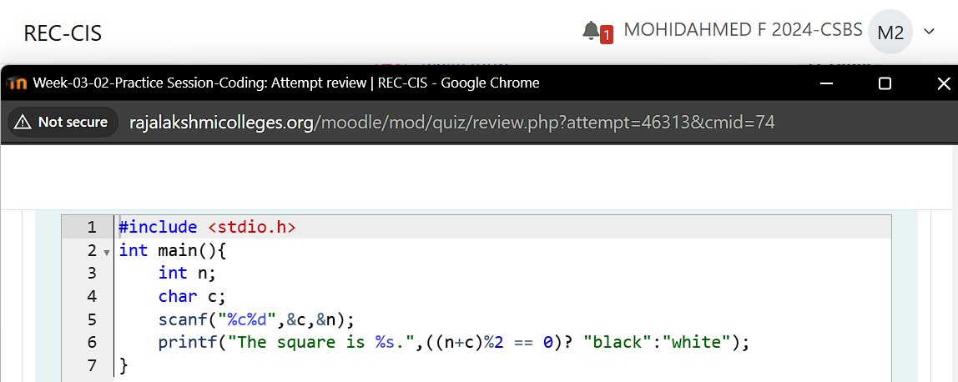

**Output:**

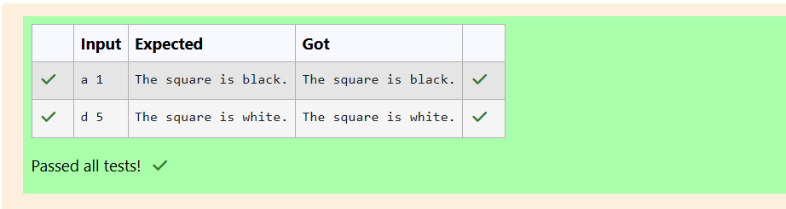

**Question 7:**

**Some data sets specify dates using the year and day of year rather than the year, month, and day of month. The day of year (DOY) is the sequential day number starting with day 1 on January 1st. There are two calendars - one for normal years with 365 days, and one for leap years with 366 days. Leap years are divisible by 4. Centuries, like 1900, are not leap years unless they are divisible by 400. So, 2000 was a leap year. To find the day of year number for a standard date, scan down the Jan column to find the day of month, then scan across to the appropriate month column and read the day of year number. Reverse the process to find the standard date for a given day of year. Write a program to print the Day of Year of a given date, month and year.**

**Sample Input 1**

**18**

**6**

**2020**

**Sample Output 1**

**170**

**Program:**

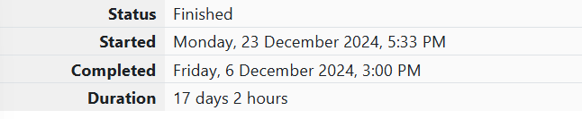

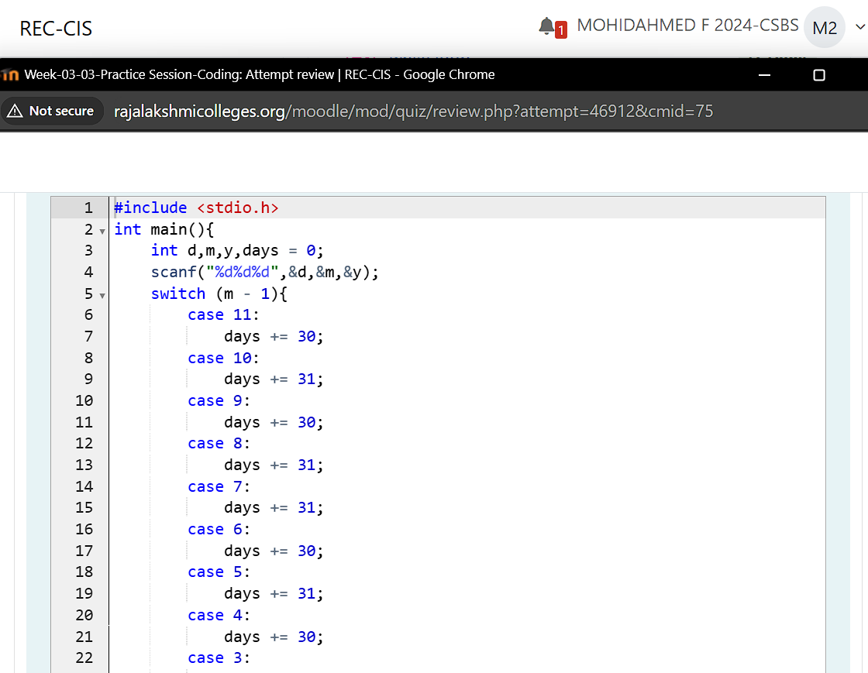

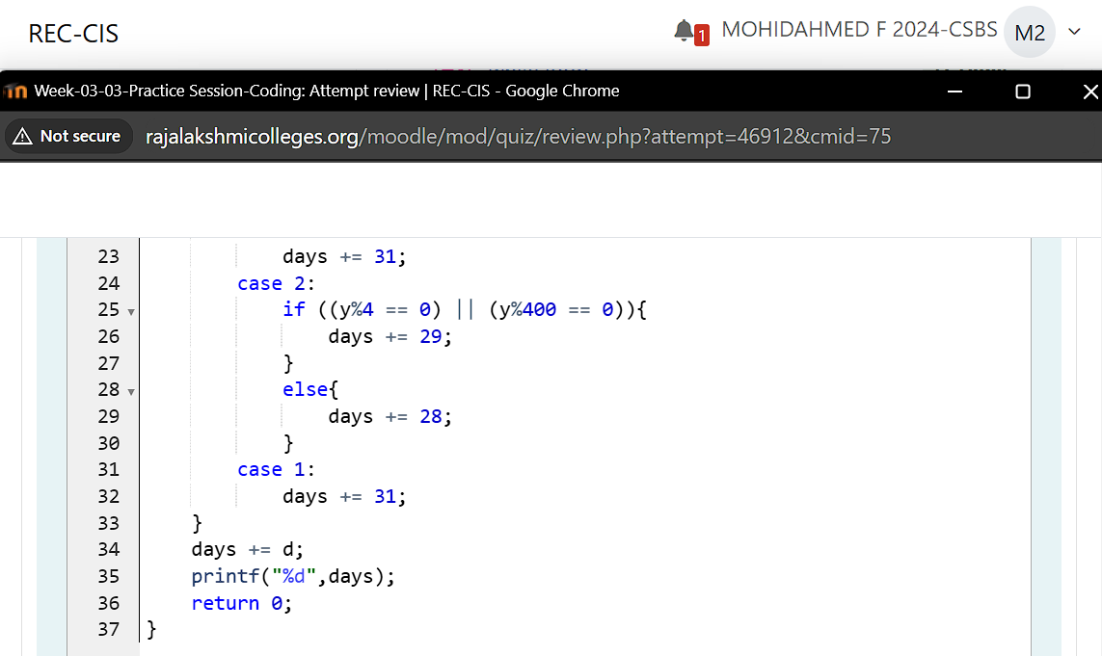

**Output:**

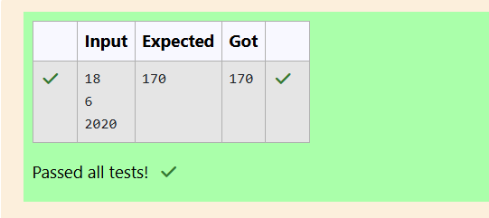

**Question 8:**

**Suppandi is trying to take part in the local village math quiz. In the first round, he is asked about shapes and areas. Suppandi, is confused, he was never any good at math. And also, he is bad at remembering the names of shapes. Instead, you will be helping him calculate the area of shapes. When he says rectangle he is actually referring to a square. When he says square, he is actually referring to a triangle. When he says triangle he is referring to a rectangle. And when he is confused, he just says something random. At this point, all you can do is say 0. Help Suppandi by printing the correct answer in an integer.**

**Input Format:**

**Name of shape, Length of 1 side, Length of other side**

**Output Format: Print the area of the shape.**

**Sample Input 1: T 10 20**

**Sample Output 1: 200**

**Program:**



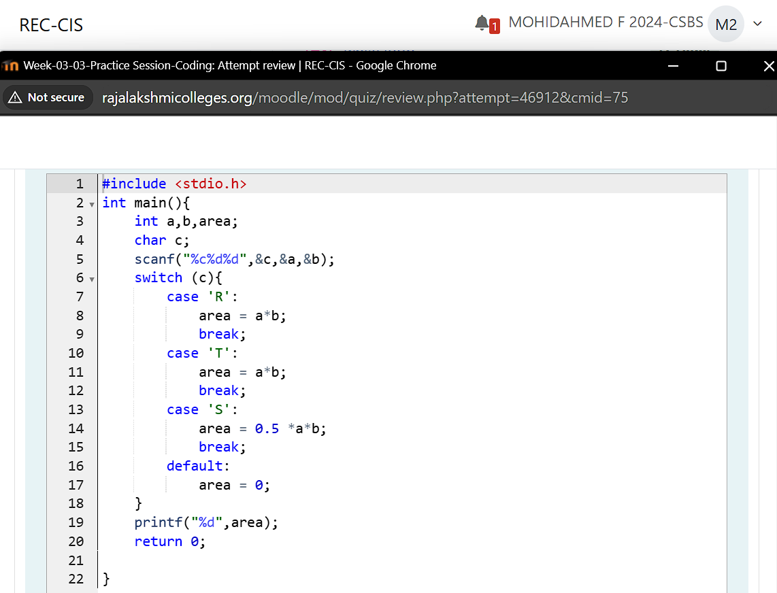

**Output:**

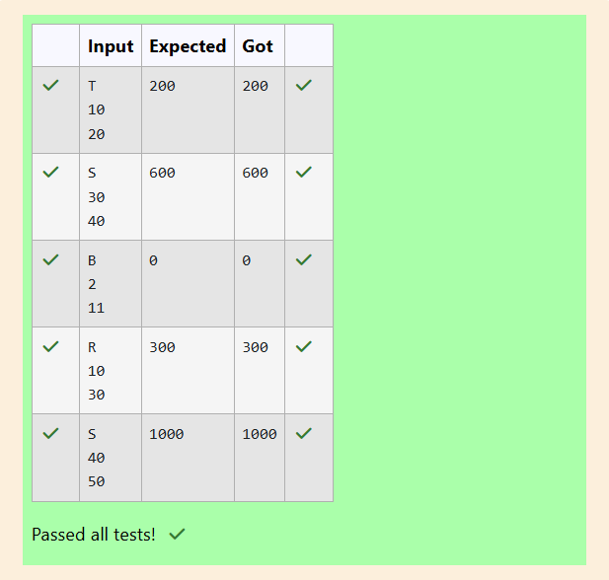

**Question 9:**

**Superman is planning a journey to his home planet. It is very important for him to know which day he arrives there. They don't follow the 7-day week like us. Instead, they follow a 10-day week with the following days: Day Number Name of Day 1 Sunday 2 Monday 3 Tuesday 4 Wednesday 5 Thursday 6 Friday 7 Saturday 8 Kryptonday 9 Coluday 10 Daxamday Here are the rules of the calendar: The calendar starts with Sunday always. It has only 296 days. After the 296th day, it goes back to Sunday. You begin your journey on a Sunday and will reach after n. You have to tell on which day you will arrive when you reach there.**

**Sample Input: 7**

**Example Output: Kryptonday**

**Program:**



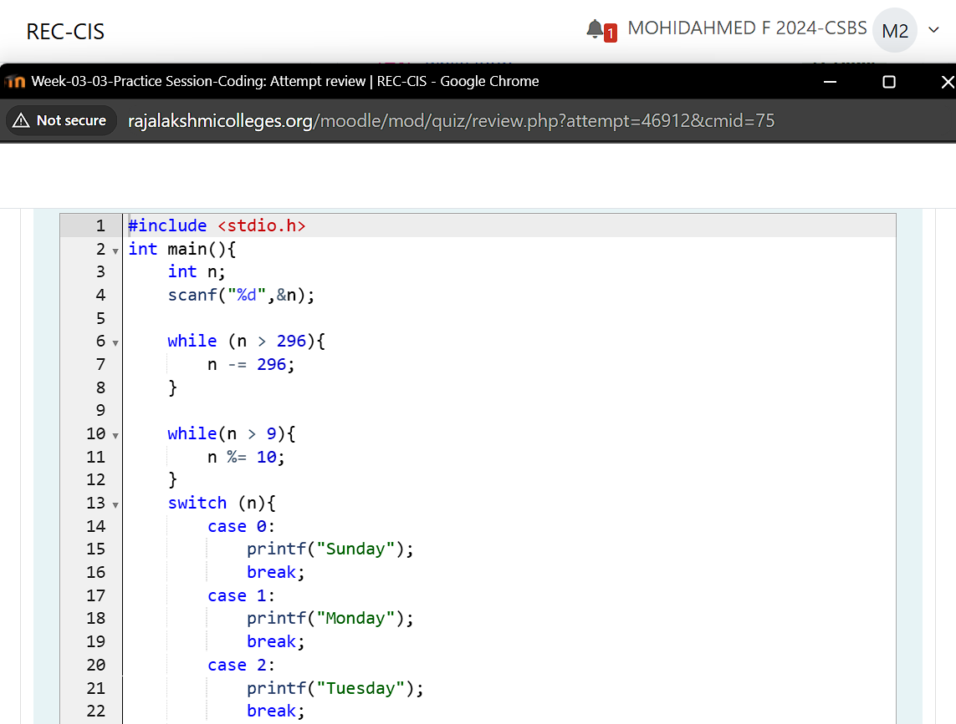

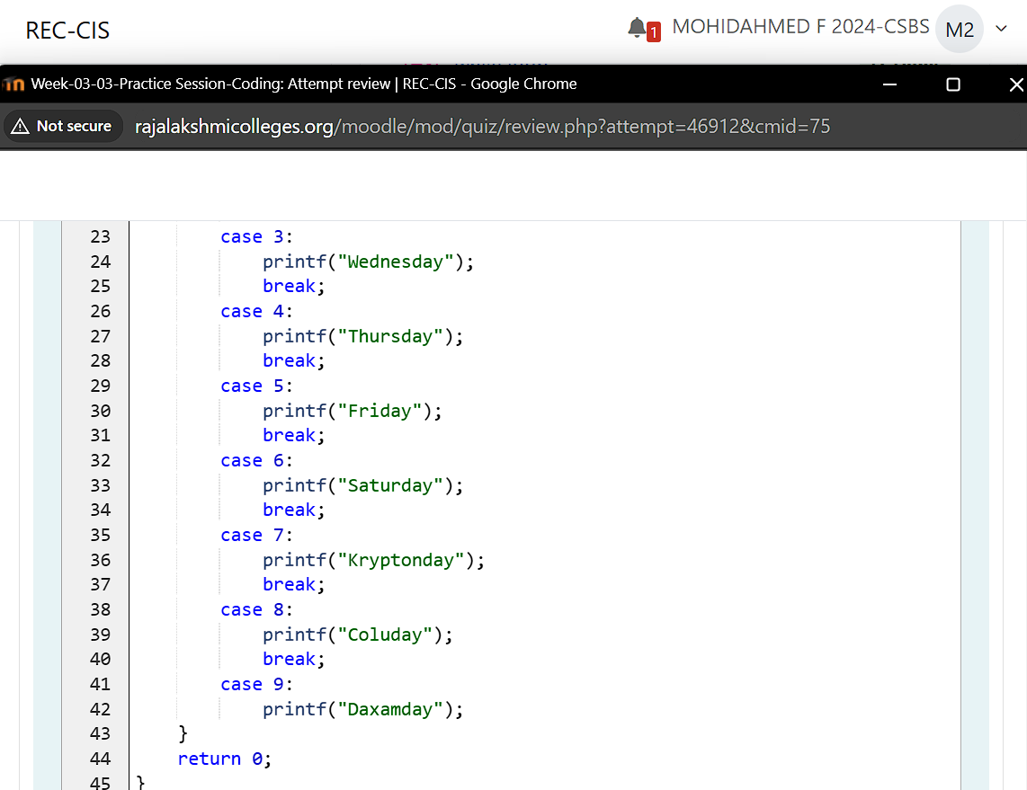

**Output:**

